Collège des Dominicaines de notre Dame de la Délivrande – Araya-
Grade 5 April 2020 – Week 2
Name : ________________________

Fable Reading - Answer Key
- Tick the correct sentence:
+ A fable is a story that teaches us about life.
+ A fable always has a moral.
The moral of this fable is: always work hard and be ready.

- Draw a picture to explain the meaning of these words:

Thick | Dig
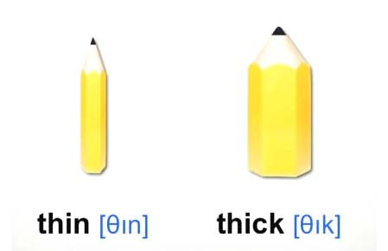

- Do the exercises on:
- CB p.48 n.4
- Violin
- Corn
- Summer
- Kind / Generous

- WB p.45 n.1-2-3
n.1: 2-b / 3-f / 4-d / 5-c / 6-h / 7-a / 8-f
n.2: 2-lazy / 3-share / 4-dig / 5-thick / 6-generous / 7-worry / 8-prepare
n.3: 2-cold hot / 3-summer winter / 4-snow food /
5-thin thick / 6-spring winter

