Collège des Dominicaines de notre Dame de la Délivrande – Araya-
Grade 4 May 2020 – Week 1
Name : ________________________

Chess

- The following text is about “Chess”.
The sentences are scrambled.
Help me put them in their correct order please.

Computers play chess. Chess is very popular. Each player gets sixteen pieces. Chess is a game for two people. “Checkmate” means that the king can’t move. Pieces are usually black and white. Pieces move in different ways. Computers sometimes win chess games against human champions. Chess is played on a chequered board. Chess is hard at the beginning. Each player gets one king, one queen, two knights, two bishops, two rooks and eight pawns. The board is black and white. The game ends when one king is in “checkmate”. Experts become better by learning special moves for each piece. Chess is a very old game.

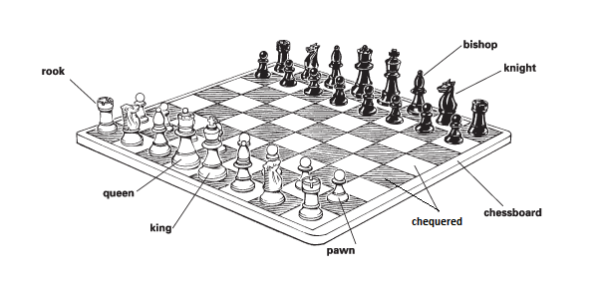

- ……………………………………………………………………………………………………………………………………
- ……………………………………………………………………………………………………………………………………
- ……………………………………………………………………………………………………………………………………
- ……………………………………………………………………………………………………………………………………
- ……………………………………………………………………………………………………………………………………
- ……………………………………………………………………………………………………………………………………
- ……………………………………………………………………………………………………………………………………
- ……………………………………………………………………………………………………………………………………
- ……………………………………………………………………………………………………………………………………
- …………………………………………………………………………………………………………………………………
- …………………………………………………………………………………………………………………………………
- …………………………………………………………………………………………………………………………………
- …………………………………………………………………………………………………………………………………
- …………………………………………………………………………………………………………………………………
- …………………………………………………………………………………………………………………………………

- Now write each sentence in the correct part.
Part 1: About Chess (Introduction)
________________________________________________________________________________________________________________________________________________________________________________________________________________________

Part 2: How to Play Chess (Body)
________________________________________________________________________________________________________________________________________________________________________________________________________________________________________________________________________________________________________________________________________________________________________________________________________________________________________________________________________________________________________________________________________________________________________________________________________________________________________________________________________

Part 3: Computers and Humans (End)
________________________________________________________________________________________________________________________________________________________________________________________________________________________

