Collège des Dominicaines de notre Dame de la Délivrande – Araya-
Grade 5 April 2020 – Week 1
Name : ________________________

Giving Directions – Answer Key

- Match.

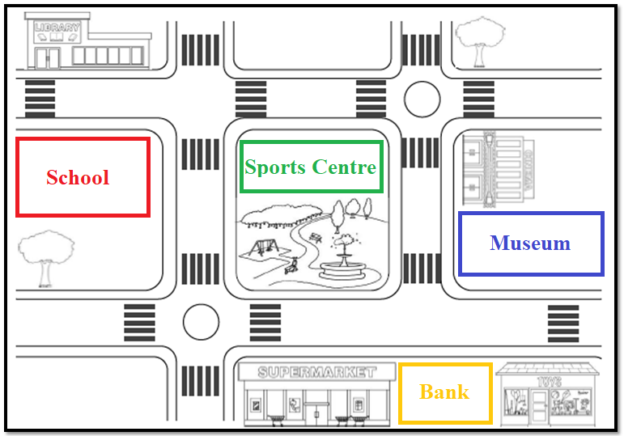
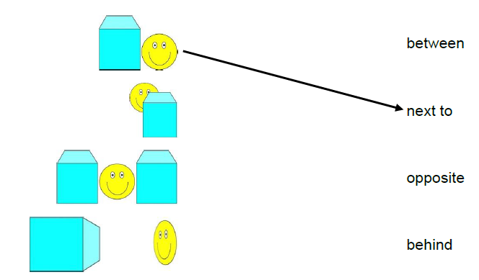
- Read the sentences and draw the places on the map.

