Collège des Dominicaines de notre Dame de la Délivrande – Araya-
Grade 5 April 2020 – Week 1
Name : ________________________

Giving Directions

- Match.

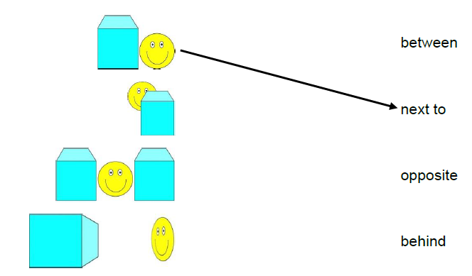
- Read the sentences and draw the places on the map.
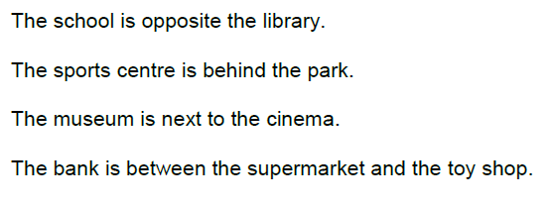

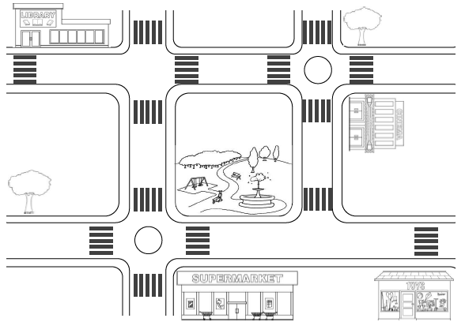

- Add 3 more places on the map. Write sentences about them.
- ______________________________________________________________________________________________________________________________________
- ______________________________________________________________________________________________________________________________________
- ______________________________________________________________________________________________________________________________________

