Collège des Dominicaines de notre Dame de la Délivrande – Araya-
Grade 4 April 2020 – Week 1
Name : ________________________

Book Review - Answer Key

- Look at the pictures. Match.
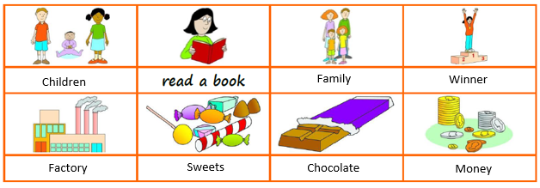

- Answer the questions with Yes or No.
- You write a review to give your opinion. Yes
- Roald Dahl is the person who wrote the review. No
- The book is about a rich family. No
- Charlie is invited to a chocolate factory alone. No
- The factory is for a man called Willy. Yes
- Gabrielle doesn’t like the other children. Yes
- Gabrielle thinks the book is fantastic. Yes

