Collège des Dominicaines de notre Dame de la Délivrande – Araya-
Grade 4 March 2020 – Week 5
Name : ________________________

The Lion and the Mouse – Answer Key

- Look at the underlined words in the text. Match.
 | 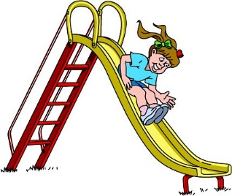 |  |  | 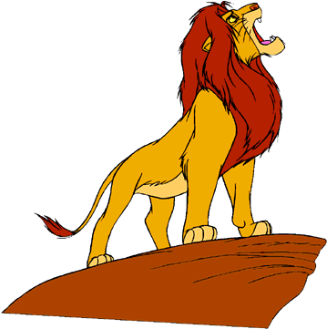
chewed | slid down | heard | caught | roared
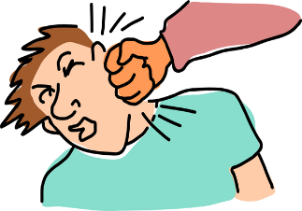 |  | 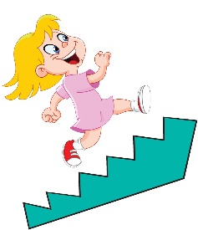 |  | 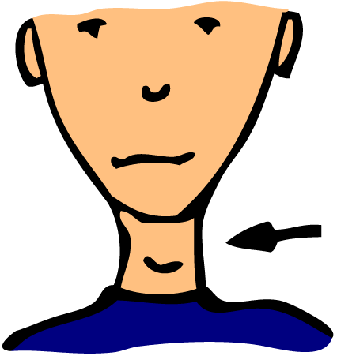
smack | tied | ran up | cried | neck

- Watch or read the story again. Put the sentences in the correct order.

2 | The little mouse ran up the lion’s neck.
6 | He saw the king of the jungle tied to a tree.
1 | A lion was asleep in the sun one day.
8 | ‘You were right, little mouse – thank you, I’m free.’
4 | ‘Be kind to me and one day I’ll help you.’
7 | The mouse worked quickly and chewed through the rope.
3 | The lion caught him with a great big smack!
5 | The mouse was out walking the very next day.

- Read and tick.
- The lion caught: an ant.

- The lion wanted to: eat the mouse.

- The mouse promised the lion that: someday, he will help him.

- The next day, the mouse saw the lion: tied to a tree.

- Write three words from the text for each part of speech.
Noun | Verb | Adjective
Mouse – lion – sun - day – neck – back – smack – mouth – roar – tree – plan – rope – hope – friend - | Came – ran – caught – eat – roared – cried – help – do – laughed – heard – said - worked – chewed - | Little – great - big – wide – kind – hard – free – best -

