Collège des Dominicaines de notre Dame de la Délivrande – Araya-
Grade 4 April 2020 – Week 2
Name : ________________________

Silly Little Poems

- Xbox, Xbox

Xbox, Xbox, you’re the one for me.
I love my 3DS, and my Nintendo Wii.

PS4, Gameboy, Apple iPad touch.
I never thought that I would be in love this much.

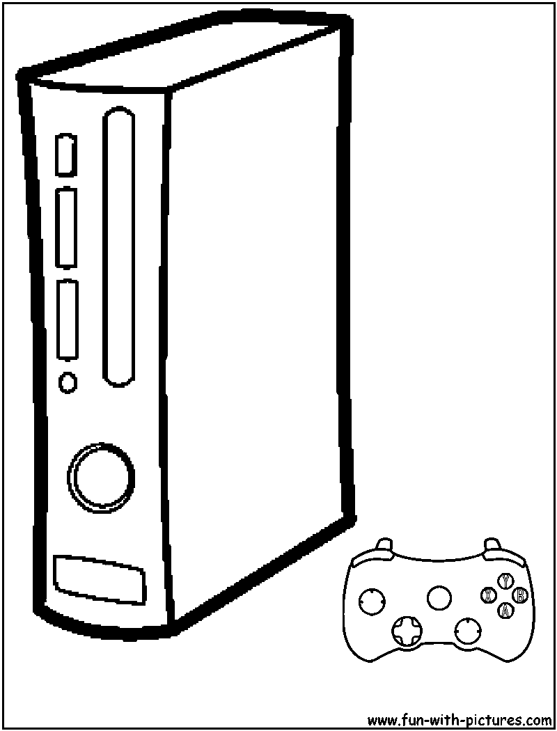
Pac-Man, Sonic, Mario and Link.
You are written on my mind with ink.

This is true love, it’s easy to see.
Xbox, Xbox, will you marry me?

- Read and write T (true) or F (false).

- I hate my Nintendo Wii. _________
- I have an iPad touch _________
- I play football on my Xbox _________
- My video games are written on my heart. _________
- I want to marry my video games one day. _________

- My Dog Lives on the Sofa

My dog lives on the sofa, that’s where he wants to be.
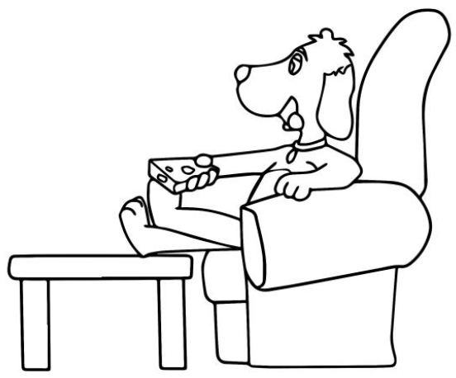
He likes to sit there and watch what’s on TV.

He changes the channels using the remote,
Then watches what he wants, I never get a vote.

He loves films with animals and nature shows,
Whenever cat cartoons are on, he always watches those.

I got him from the dog shop. I got him for free.
He does nothing! He’s always watching TV!

- Circle the correct answer.

- The dog lives / sleeps on the sofa.
- He sometimes / always watches TV.
- He changes the channels using a remote / wooden stick.
- The dog loves watching basketball matches / nature shows on the TV.
- The dog came from a dog shop / Australia.

- Wayne the Dinosaur

Meet Wayne the dinosaur,
He isn’t very smart, he can’t count to four.
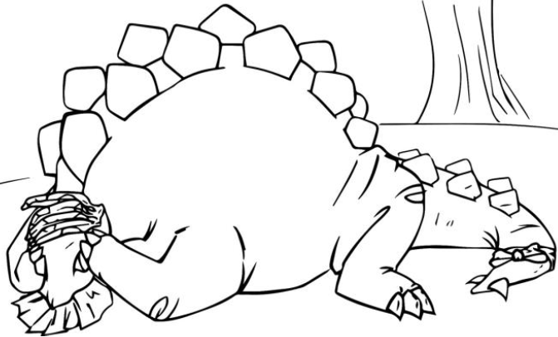
He’s long, heavy and tall,
But his brain is really small.

He doesn’t know what’s up and down,
He thinks the sky is chocolate brown.

Wayne thinks that black is white,
And sleeps with bananas on his head at night!

- Read and correct the mistakes in the sentences.

- Dwayne the dinosaur can’t count to four.
________________________________________________________________

- The dinosaur is short.
________________________________________________________________

- Wayne’s brain is really big.
________________________________________________________________

- He thinks that the sky is blue.
________________________________________________________________

- The dinosaur sleeps with bananas on his head during the day.
________________________________________________________________

- Tick Tock
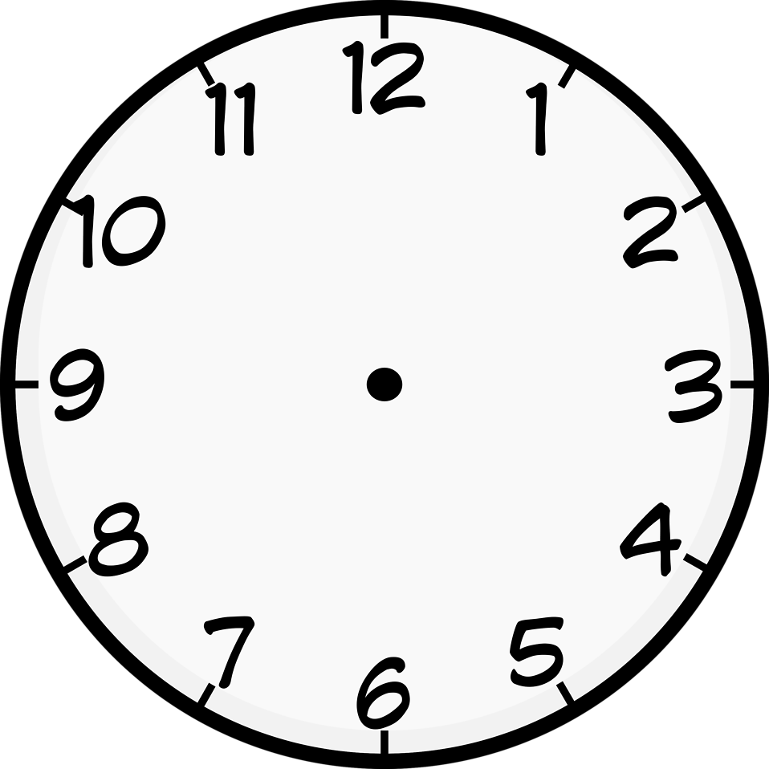
Tick tock, tick tock,
Grandpa can’t silence his clock!

Swing swing, swing swing,
We’re listening to a terrible thing.

Swing swing, swing swing,
We want the clock to stop ringing.

Ding dong, ding dong,
Now it plays a horrible little song.

- Read and answer the questions with Yes or No.

- Can Grandpa silence his clock? ________
- Are they listening to a bad thing? ________
- Do they want the clock to stop ringing? ________
- Is the clock playing a nice song? ________
- Do they hate the clock’s song? ________

