Collège des Dominicaines de notre Dame de la Délivrande – Araya-
Grade : 4 April 2020 – Week 1
Name : ________________________

Book Review
- Look at the pictures. Match.
Read a book – Children – Money – Factory – Winner – Chocolate – Family - Sweets

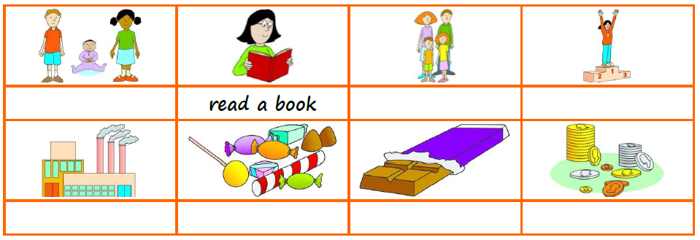

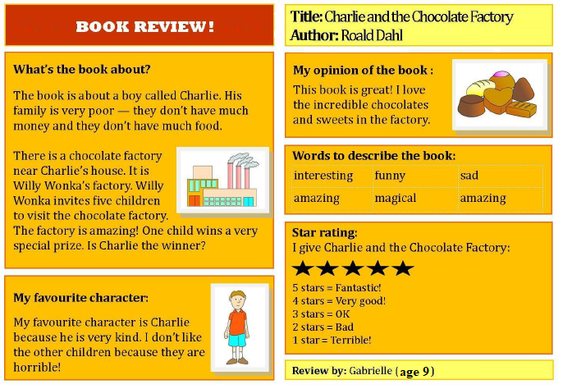
- Read the book review.

- If you can’t read the book, click on the link to watch 5 parts of the movie: Movie Parts

- Answer the questions with Yes or No.
- You write a review to give your opinion. __________
- Roald Dahl is the person who wrote the review. __________
- The book is about a rich family. __________
- Charlie is invited to a chocolate factory alone. __________
- The factory is for a man called Willy. __________
- Gabrielle doesn’t like the other children. __________
- Gabrielle thinks the book is fantastic. __________

- Now it’s your turn to write a book review. Here are some tips to help you:
- Choose any book (English, French or Arabic)
- Write the title of the book and the author’s name.
- Talk about the story, but don’t say the ending.
- Write about one thing you liked and one thing you didn’t like.
- Use adjectives to describe the book.
- Give the book a star rating.
- Don’t forget your name and your age.
- Use the sample on the next page, or you can make one of your own.
- Optional: Shoot a video of yourself reviewing the book, and send it to the school’s Facebook page so your family, friends and teaches can watch it!

