Collège des Dominicaines de notre Dame de la Délivrande – Araya-
Grade 3 March 2020 – Week 5
Name : ________________________

My Day - Answer Key

- Match.

Help my mum
Play with my brother/sister
Listen to music
Read a book
Watch TV
Do my homework
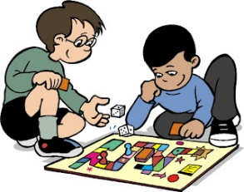
Play the piano

- CB p.62 n.3:

- Eight seven
- Evening morning
- Yellow blue
- Teacher doctor
- Five two

- Talk about your day. Write 4 sentences. Use the 4 parts of the day.

- In the morning, I do my homework and I listen to music.
- I help my mum in the afternoon.
- I play the piano and I watch TV in the evening.
- At night, I read a book.

