Collège des Dominicaines de notre Dame de la Délivrande – Araya-
Grade 3 April 2020 – Week 1
Name : ________________________

My Day… in a Video

- Read the instructions. Make a clock. Ask your mum or dad for help.

- Cut out the clock,
- Glue the clock to a paper or a plastic plate,
- Make a hole in the clock and the plate,
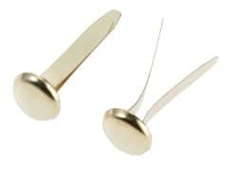
- Cut out the big hand and the small hand,
- Use a paper fastener to attach the hands to the clock.
- Decorate your clock with stickers and pretty shapes (smiley faces, emojis…)

- Let’s get creative:
- Use the clock to talk about your day.
- Shoot a 1 minute video with the help of your mum or dad.
- Send the video to the school’s Facebook page so your family, friends and teachers can watch it.

