Collège des Dominicaines de notre Dame de la Délivrande – Araya-
Grade 2 April 2020 – Week 1
Name : ________________________

My Restaurant – Answer Key

- Match.
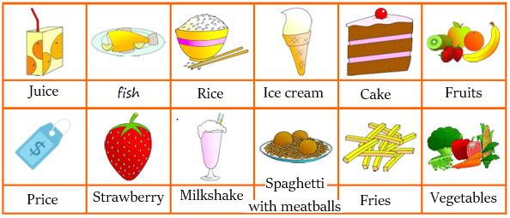

- Read the menu. Circle the correct answer.
- There are four meals / five meals on the menu
- There is a cheese and tomato / pepperoni pizza on the menu.
- There is vanilla or chocolate / strawberry ice cream on the menu.
- There is a banana cake / chocolate cake on the menu.
- There is apple / orange juice on the menu.

