Collège des Dominicaines de notre Dame de la Délivrande – Araya-
Grade 2 April 2020 – Week 1
Name : ________________________

My Restaurant
- Match.
Fish – Cake – Spaghetti with meatballs – Rice – Strawberry – Juice – Milkshake – Price – Fruits – Fries – Ice cream - Vegetables

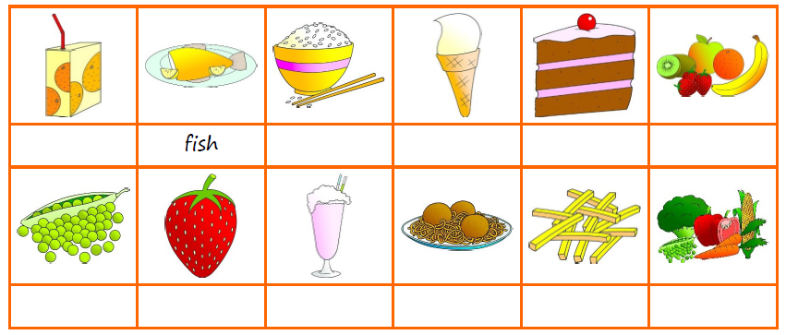

- Read the menu. Circle the correct answer.
- There are four meals / five meals on the menu
- There is a cheese and tomato / pepperoni pizza on the menu.
- There is vanilla or chocolate / strawberry ice cream on the menu.
- There is a banana cake / chocolate cake on the menu.
- There is apple / orange juice on the menu.
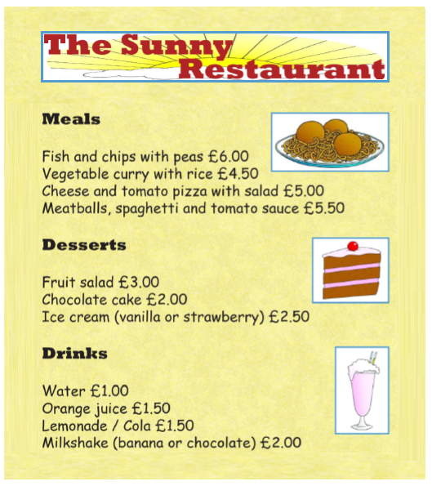

- Now write your own menu!
- Write the name of your restaurant,
- Write the meals, desserts and drinks on the menu,
- Write the prices,
- Draw some pictures and decorate your menu.
