The Past Simple: Negative Form

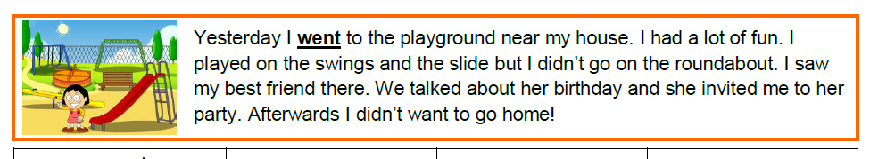
- Read the text. Underline the verbs in past simple positive form.

- Look at the sentences below.
Read the questions and tick ( ) the correct answer.
- Yesterday I went to the playground near my house.
- Yesterday I didn’t go to the playground near my house.
- What form is used in the first sentence?  positive  negative  question | - What form is used in the first sentence?  positive  negative  question
- What word did we add to change the sentence to the negative form?  didn’t  on  roundabout | - After adding “didn’t” to change the sentence to the negative form, what happened to the verb?  nothing changed  we used the infinitive of the verb  we used the past simple of the verb
Let’s Learn:
+ To change a verb in the past simple from positive to negative,
we add “didn’t” before the verb.
+ In the negative form, we use the infinitive form of the verb.

- Match the verbs with their past simple form.

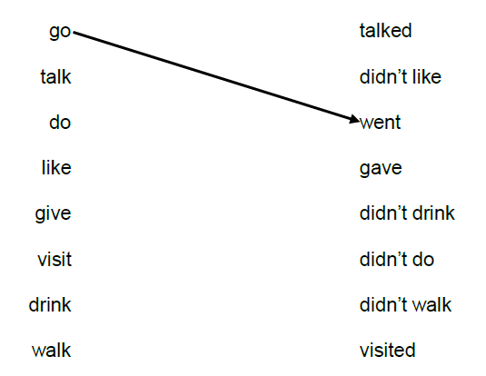
- Find the mistake in each sentence. Underline it and correct it.
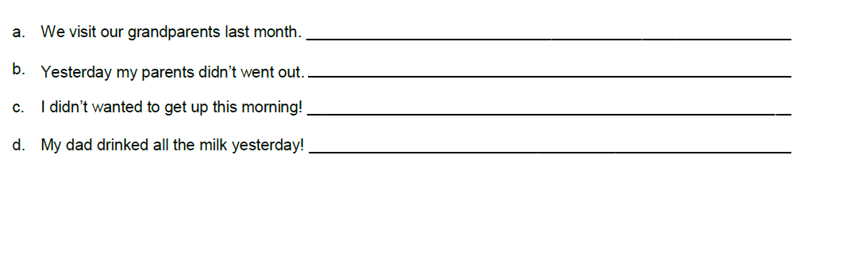

- Complete the sentences. Write the past simple of the verbs in brackets.

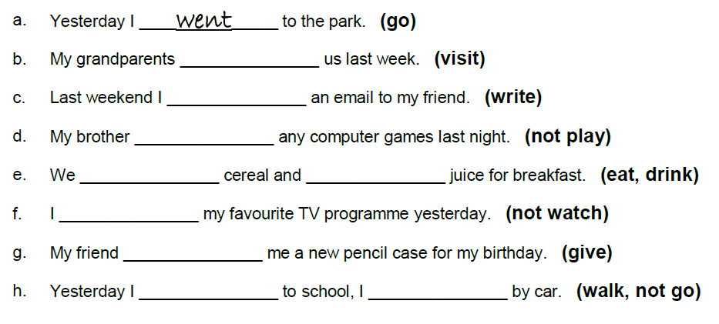
- Let’s play!
Dear parents,
During this critical situation, where we all have to stay home to remain safe and healthy, I present you with some “pencil and paper” activities to help you spend more time with your kids and just have fun together. You just need a pencil and a paper to have fun!
Make good use of them and let them be a small reminder of the fun time we can all have with our families, even if it’s just 30 minutes a day.
It’s impossible to waste time when spent with our families.

URL:
https://www.todaysparent.com/family/activities/pencil-and-paper-games/#gallery/pencil-and-paper-games-for-kids/slide-1

