The Past Simple: Negative Form.

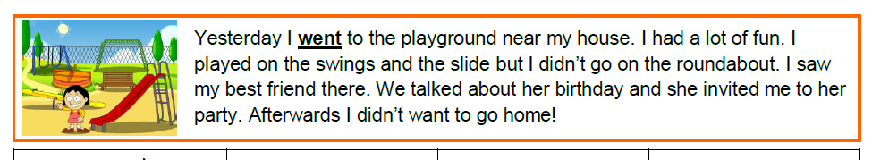
- Read the text. Underline the verbs in past simple positive form.

- Look at the sentences below.
Read the questions and tick ( ) the correct answer.
- Yesterday I went to the playground near my house.
- Yesterday I didn’t go to the playground near my house.
- What form is used in the first sentence?  positive  negative  question | - What form is used in the first sentence?  positive  negative  question
- What word did we add to change the sentence to the negative form?  didn’t  on  roundabout | - After adding “didn’t” to change the sentence to the negative form, what happened to the verb?  nothing changed  we used the infinitive of the verb  we used the past simple of the verb

- Match the verbs with their past simple form.
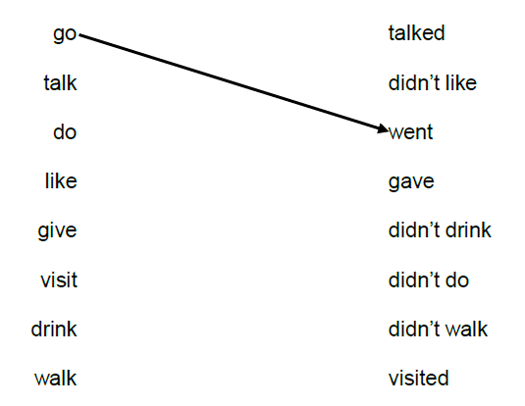

- Find the mistake in each sentence. Underline it and correct it.

- visit visited
- went go
- wanted want
- drinked drank

- Complete the sentences. Write the past simple of the verbs in brackets.

- went
- visited
- wrote
- didn’t play
- ate – drank
- didn’t watch
- gave
- walked – didn’t go

