Name: Grade 5 A - B

Extra Practice Worksheet - March 2020

1 Circle the correct words.
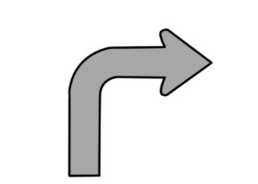  1 | turn left / turn right /  go back | 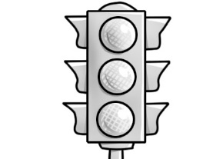  2 | roundabout / map /  traffic lights
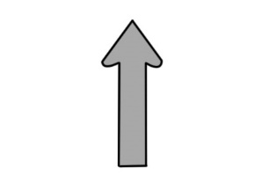  3 | turn right / go back /  go straight on | 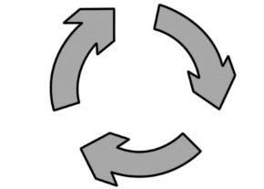  4 | map / roundabout /  traffic lights
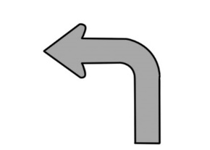  5 | turn right / go back /  turn left | 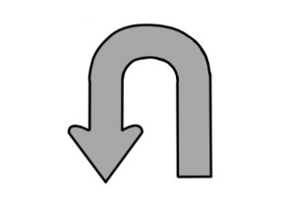  6 | go back / turn left /  go straight on
2 Write sentences in the simple past using the verbs. Add time markers.
1 Use: They used three coloring pencils last night.
2 Run: He ran quickly yesterday.
3 Play: Rob and Tammy played chess last week.
4 Go: I went to school four days ago.
5 Buy: My mum bought a new dress two weeks ago.
6 Watch: We watched a horror movie yesterday evening.
3 Today is Joe’s first day at his new school, but he got lost!
Help him get to school by giving him directions.

- Go straight on.
- Turn right at the roundabout.
- Go straight on.
- Turn left at the traffic lights.
- Go straight on.
- The school is on your left.

/10

