Collège des Dominicaines de notre Dame de la Délivrande – Araya-
Classe : CM2 Mars 2020 – 2ème semaine
Nom : ________________________

1 Circle the correct words.
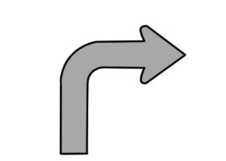  1 | turn left / turn right /  go back | 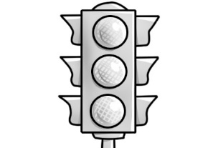  2 | roundabout / map /  traffic lights
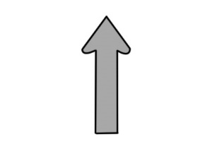  3 | turn right / go back /  go straight on | 4 | map / roundabout /  traffic lights
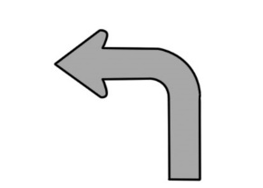  5 | turn right / go back /  turn left | 6 | go back / turn left /  go straight on
2 Write sentences in the simple past using the verbs. Add time markers.
1 Use: _______________________________________________________________
2 Run: _______________________________________________________________
3 Play: _______________________________________________________________
4 Go: ________________________________________________________________
5 Buy: ________________________________________________________________
6 Watch: ______________________________________________________________

3 Today is Joe’s first day at his new school, but he got lost!
Help him get to school by giving him directions.

________________________________________________________________________
________________________________________________________________________
________________________________________________________________________________________________________________________________________________________________________________________________________________________________________________________________________________________________________

/10

