|  |  |
| --- | --- |
| Collège des Dominicaines de notre Dame de la Délivrande – Araya-  Grade 4March 2020 – Week 5  Name : ________________________ | Logo.jpg |

**The Lion and the Mouse**

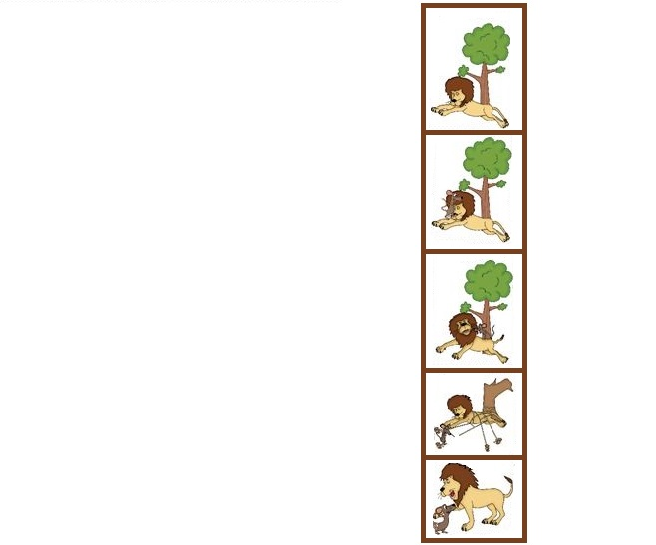A lion was asleep in the sun one day.

A little mouse came out to play.

The little mouse ran up the lion’s neck and slid down his back.

The lion caught him with a great big smack!

“I’m going to eat you!” the lion roared, his mouth open wide.

“No, no, please don’t!” the little mouse cried.

“Be kind to me and one day I’ll help you.”

“I’m a lion! You’re a mouse! What can you do?”

The lion laughed, very hard, and the mouse ran away.

But the mouse was out walking the very next day.

He heard a big roar, and squeaked when he saw the lion tied to a tree.

But the mouse had a plan to set him free.

The mouse worked quickly and chewed through the rope.

The lion said, “Oh little mouse, I had no hope.

You were right, little mouse – thank you, I’m free.

You’re the best friend there ever could be!”

[Watch the story here!](https://learnenglishkids.britishcouncil.org/short-stories/the-lion-and-the-mouse)

1. Look at the underlined words in the text. Match.

***ran up – neck – slid down – caught – smack –***

***roared – cried – heard – tied – chewed***

|  |  |  |  |  |
| --- | --- | --- | --- | --- |
|  |  |  |  |  |
|  |  |  |  |  |
|  |  |  |  |  |
|  |  |  |  |  |

1. Watch or read the story again. Put the sentences in the correct order.

|  |  |
| --- | --- |
|  | The little mouse ran up the lion’s neck. |
|  | He saw the king of the jungle tied to a tree. |
| 1 | A lion was asleep in the sun one day. |
|  | ‘You were right, little mouse – thank you, I’m free.’ |
|  | ‘Be kind to me and one day I’ll help you.’ |
|  | The mouse worked quickly and chewed through the rope. |
|  | The lion caught him with a great big smack! |
|  | The mouse was out walking the very next day. |

1. Read and tick.
2. The lion caught:

|  |  |
| --- | --- |
|  | An ant |
|  |  |
|  | A mouse |
|  |  |
|  | A rat |

1. The lion wanted to:

|  |  |
| --- | --- |
|  | Eat the mouse |
|  |  |
|  | Play with the mouse |
|  |  |
|  | Have lunch with the mouse |

1. The mouse promised the lion that:

|  |  |
| --- | --- |
|  | Someday, he will fight him |
|  |  |
|  | Someday, he will help him |
|  |  |
|  | Someday, he will visit him |

1. The next day, the mouse saw the lion:

|  |  |
| --- | --- |
|  | Playing the piano |
|  |  |
|  | Tied to a tree |
|  |  |
|  | Brushing his teeth |

1. Write three words from the text for each part of speech.

|  |  |  |
| --- | --- | --- |
| Noun | Verb | Adjective |
|  |  |  |
|  |  |  |
|  |  |  |