Adjectives

- Just like in French, adjectives are words we use to talk about people, animals and things.
- Colors (red, blue, yellow…) and feelings (sad, happy, hungry…) are adjectives.
- Read. Color the adjectives.
book
dog
blue
bike
play
red
long
mother
car
boy

ball
short
big
happy
small
orange

- Write.
Big Fast Sad Long
Happy Ugly Short

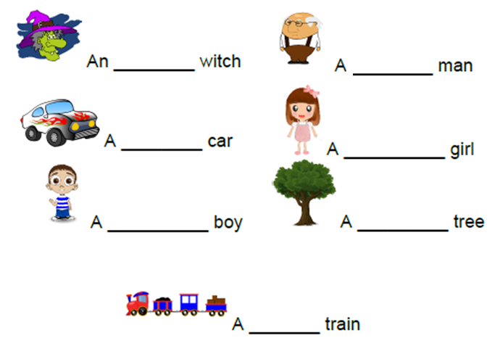

- Talk about your family using adjectives. Write 3 sentences.
_________________________________________________________________________________________________________________________________________________________________________________________________________

