He - She

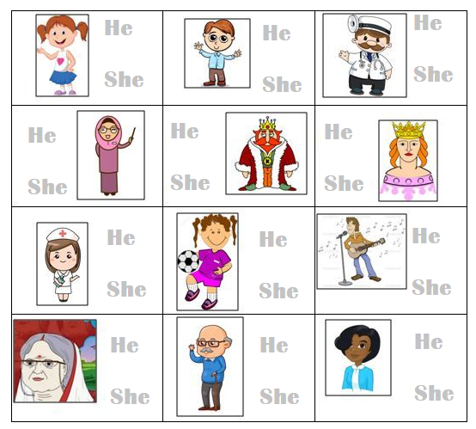
- Look at the pictures. Trace the correct word.
He
He

She
He

She
She

He

She
She

He

She
She

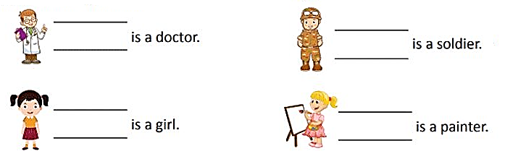
- Look at the pictures. Write He or She.

He
He

She
She

