Name: Grade 2 A - B

Extra Practice Worksheet - March 2020
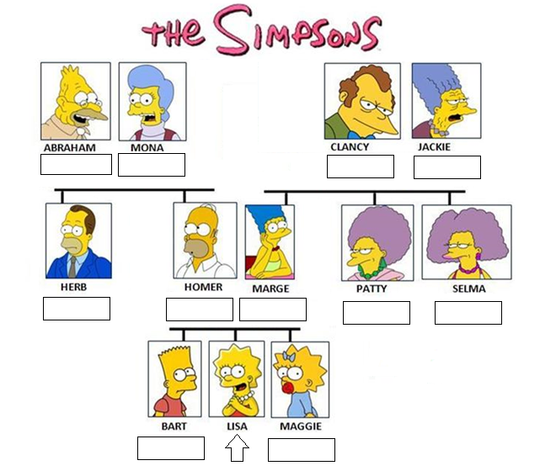

Grandma
Grandpa
Grandpa
Grandma

Mum
Dad
Uncle
Aunt
Aunt

Sister
Brother

- Look at the family tree again. Complete the text.
This is Lisa Simpson. Her mum and dad are Marge and Homer. Her sister is Maggie and her brother’s name is Bart.
Lisa has two aunts: Patty and Selma, and only one uncle, his name is Herb. She doesn’t have any cousins.
Abraham is her grandpa and Mona is her grandma. Clancy and Jackie are Marge’s mum and dad. Lisa loves her grandparents.

