Collège des Dominicaines  de notre Dame de la Délivrande – Araya  Classe : grade 10  Name and last Name:________________  Numéro sur la liste : ______ |  |  |  | Composition: Worksheet C2  Date:  Durée:
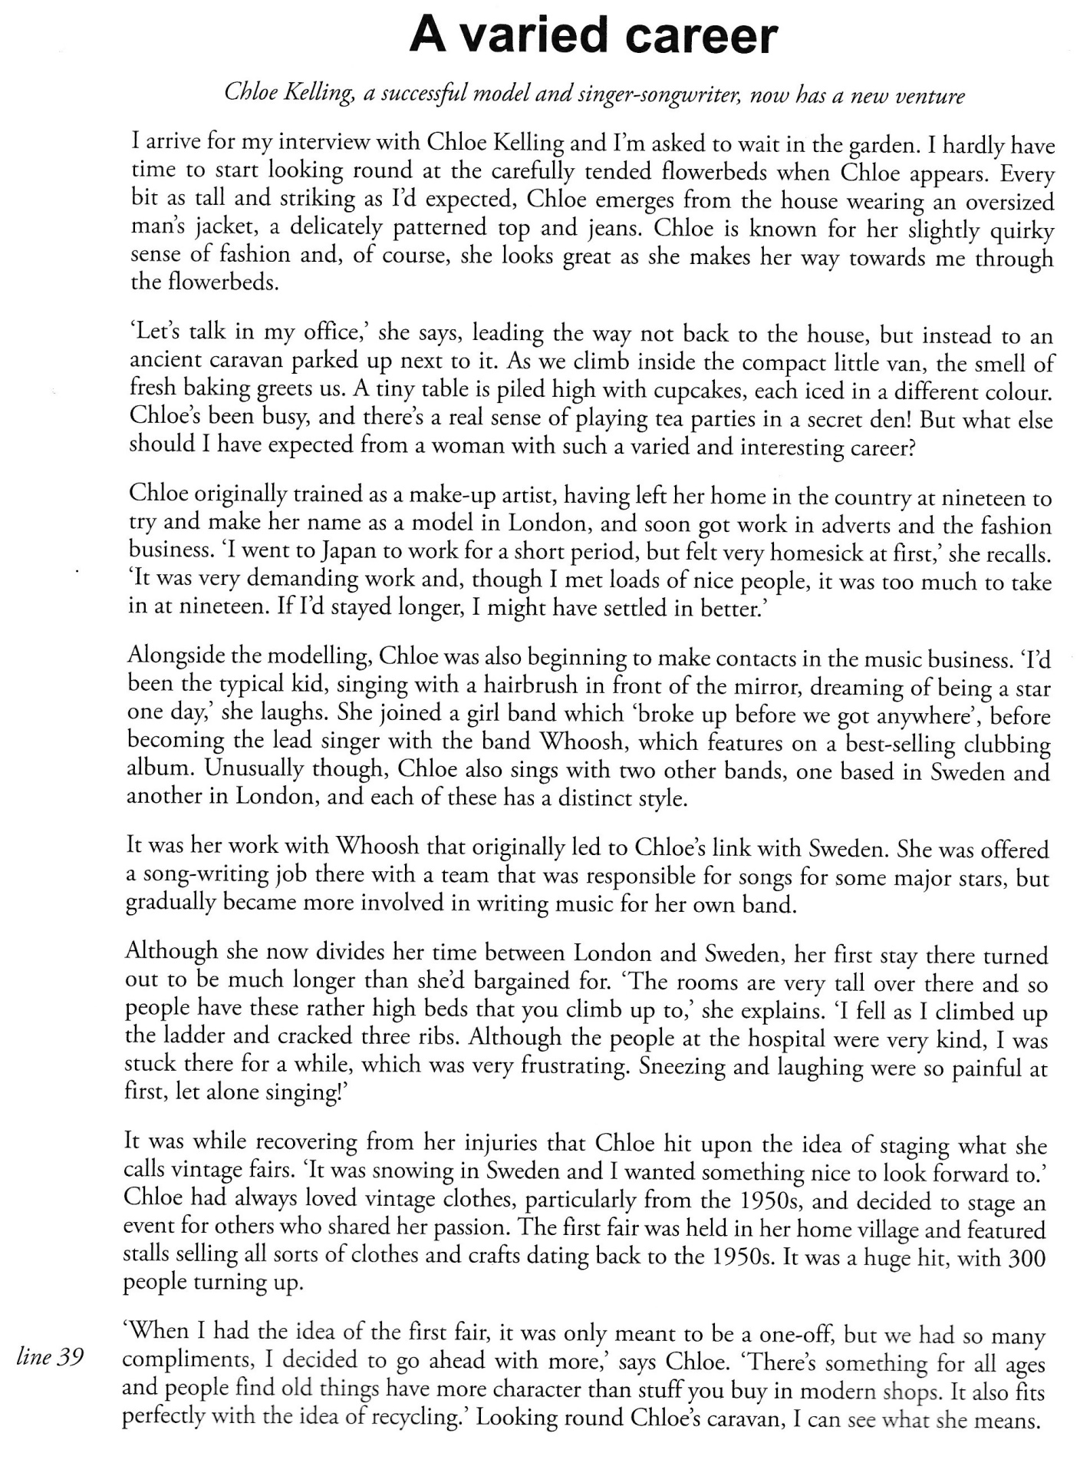
- Comprehension
- Does Chloe Kelling have a fortunate varied career?
____________________________________________________________________________________________________________________________________________________
- What was her first job? Second job?
______________________________________________________________________________________________________________________________________________________________________________________________________________________________
- Did her new venture “vintage fair” pay off?
______________________________________________________________________________________________________________________________________________________________________________________________________________________________

- Write the underlined words from the text with their correct definition.
- __________________: activities involving skill in making things by hand.
- __________________: many stands, booths, or compartments for the sale of goods in a market or large covered area.
- __________________: a gathering of stalls and amusements for public entertainment.
- __________________: the fact of being harmed or damaged.
- __________________: series of curved bones.
- __________________: different from the ordinary in a way that causes curiosity.
- Grammar
- Complete the text with the correct past simple, past perfect or past perfect continuous form.
After I’d had breakfast, I _____________________ (drive) to work and arrived about 15 minutes early. I definitely _____________________ (not look) forward to going to work that Tuesday because the boss had asked me to see him at 9.30. This was unusual. He _____________________ (never ask) to see me in his office before. I knew I _____________________ (do) something wrong. I sat at my desk for ten minutes because I knew he _____________________ (like) punctuality and then I knocked on his door. Surprisingly, he _____________________ (smile) when I went in. He obviously knew that I was waiting for the right moment.

- Gerund and infinitives. Write the correct form of the verb.
- I like ____________ (check) the information online.
- The teacher told us to stop ____________ (write) before I had finished.
- I’ll never forget ____________ (meet) our Head Teacher for the first time.
- I stopped ____________ (work) at 10.30 for 15 minutes.
- I remember ____________ (do) this test last year.
- Stop ____________ (write) now please. That’s the end of the exam.
- Circle the correct alternatives.
- Let’s play tennis later, and I’ll record/I am recording the film to watch tomorrow.
- Who’s coming/will come on the school trip? I hope Eddie and Martin are coming.
- I’ve heard that Disney is going to make/makes an animated sci-fi film sometime next year.
- The instructions in the letter say that we are to wait at the entrance until someone will come/comes to show us to the right room.
- Do you think that one day in the future we’ll have been living/be living on another planet?
- By the end of this game, I’ll have beaten/been beating you six times.
C. Vocabulary
- Circle the correct alternatives to complete the advertisement.
Have you resigned recently because you hated your last job? Or maybe you’ve been made (1) ___? Apply for a job with Grant and Company Ltd. and you could be (2) ___ a high salary within months. We are looking for people who would like the (3) ___ of working for an excellent employer who can guarantee a secure full-time job for the next two years with the opportunity for plenty of (4) ___. We also offer excellent working (5) ___. You don’t need many (6) ____ but you need to be hard working and punctual. Check out the positions on offer on our website and get more information. Who knows, your dream job could be one click away!
1 A retired B redundant C dismissed D unemployed
2 A finding B looking C earning D winning
3 A talent B experience C responsibility D money
4 A overtime B part-time C self-employed D qualifications
5 A situations B conditions C time D holidays
6 A overtime B part-time C self-employed D qualifications

- Re-write the words with their appropriate prefix.
- He had been _______________ (stoppable) for a long time.
- He remembered attempting to re-enter Golath’s orbit but he had _______________ (calculate) his speed.
- Harry had tried to _______________ (able) the automatic controls, but this had been ________________ (possible).
- He knew it had been ____________________ (responsible) of him to take the craft in the first place.
- He knew he shouldn’t _______________ (estimate) the anger of the leader of Agron.

- Complete the text with suffixes. Use the words in brackets to form a noun that fits in the gap.
What kind of job would suit your personality?
If you want to be a _________________________ (perform), you need to be creative sort of a person, and have plenty of _________________________ (confident) so you will feel comfortable in front of an audience. If you want to be a ____________________ (science), you need a logical mind and you need to enjoy working on small, detailed tasks. Whatever you decide you want to do, it is important to get a good ____________________ (educate) and ____________________ (profess) that you think will bring you __________________ (happy) in your working life.

- Complete the sentences with adjectives of personality.
- If you are ________________, it means you aren’t generous with your money.
- Being ________________ is the opposite of being self-confident.
- If someone is ambitous but in a negative way, they are ________________.
- His friends say he’s determined, but other people say he’s ________________.
- She’s twenty-five but she’s quite ________________, because she acts like she is still like a child.
- A ________________ student is one who has an impressive natural ability.

- Write the particle to form phrasal verbs.
- Set ___________: start a new business, office, etc
- Get __________: progress faster than other people.
- Turn __________: no accept an offer, request or application.
- Work __________: spend time working or improving something.
- Fill __________: add information to a document.
- Take __________: take control of something.

